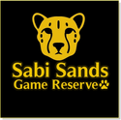

Sabi Sands Incredible Wildlife Safari - MalaMala Camp

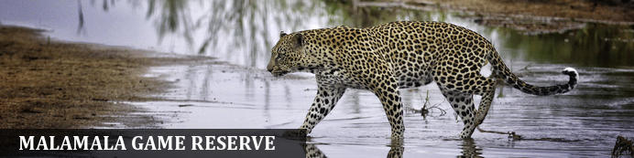
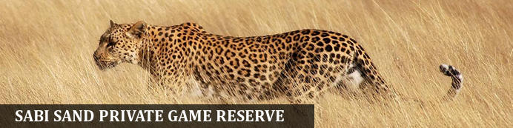
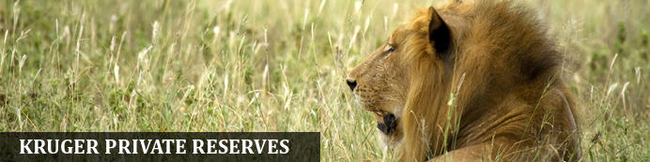

Doreen Harris & Family

Sabi Sands Incredible Wildlife Safari - MalaMala Camp
MalaMala Game Reserve
4 Days / 3 Nights
0 Persons
Date of Issue: 15 October 2020
30 October 2020 - 02 November 2020

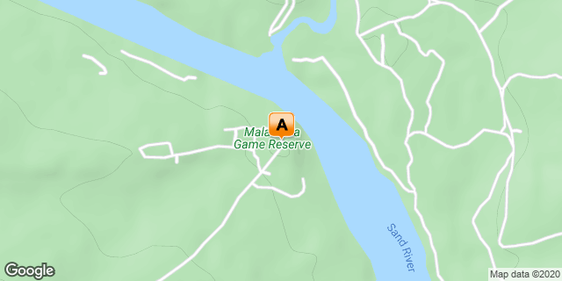

Click here to view your Digital Itinerary

Introduction
MalaMala Camp is the oldest and most historical private game reserve in South Africa and the first to make the transition from hunting to photographic safaris. It is the blueprint on which the South African safari industry was built. Every aspect of the MalaMala Main Camp is designed to appreciate and enjoy the view of the surrounding wilds. Pathways wind their way along the perimeter of the camp to reveal individual ochre colored units tucked into the greenery which flanks the Sand River. Massive trees and rolling green lawns are filled with birdsong, with the occasional antelope or elephant which seeks the succulence of greenery. The camp is unfenced – an oasis in the middle of the bushveld.

Accommodation | Destination | Start | End | Basis | Room Type | Duration
MalaMala Camp | MalaMala Game Reserve | 30 Oct | 2 Nov | FB+ | 1x Luxury Room(s) | 3 Nights

Key
FB+: Full Board Plus - Dinner, Bed, Breakfast, Lunch and Activities

Price
Price per/person per/night: ZAR 5900.00
Normal price: USD 980.00 per/person per/night
1 x triple river view luxury family room
Community levies excluded: ZAR 165.00 per/person per/night
Total: ZAR 54585.00

Included
- Accommodation for 2 nights at MalaMala Camp including all meals & 2 game drives.

Excluded
- Flights, transfers & drinks
- Phone calls & personal purchases
- Community levies & entrance fees.
- Gratuities

Day 1: MalaMala Camp, MalaMala Game Reserve (Fri, 30 October)

MalaMala Game Reserve
Situated in the northeastern reaches of South Africa in the province of Mpumalanga, MalaMala Game Reserve shares a boundary with the Kruger National Park. MalaMala is one of the largest Big Five game reserves in Southern Africa. Stretching over 13 300 hectares, this spectacular reserve features bushveld, vast savannah, riverine woodlands, and straddles the Sand River. MalaMala is one of the more established private reserves as well as one of the oldest private reserves in the greater Kruger Park region. Commonly spotted animals include lion, leopard, buffalo, elephant and rhino.

Day Itinerary
- Check in between 12h00 & 14h00
- Lunch will be served at the lodge
- Sunset game drive
- Dinner at the lodge.

Overnight: MalaMala Camp View iBrochure

Reference No: WB2551
MalaMala Game Reserve consistently produces the most exciting wildlife experience this side of the equator! The Safari Industry's blueprint to the luxury photographic safari, MalaMala has been custodian of this massive thriving tract of land since 1927.
MalaMala Game Reserve is one of the largest private Big Five game reserve in South Africa. Comprising 13 300 ha (33 000 acres), MalaMala shares a 19 km (12 mile) unfenced border with the world-renowned Kruger National Park, and lies strategically sandwiched between the National Park and the Sabi Sand Reserve.
Every aspect of MalaMala Camp and Sable Camp is designed to appreciate and enjoy the view of the surrounding wilds. Pathways wind their way along the perimeter of the camp to reveal individual ochre colored units tucked into the greenery which flanks the Sand River. Massive trees and rolling green lawns are filled with birdsong, with the occasional antelope or elephant which seeks the succulence of greenery.
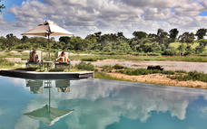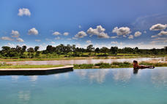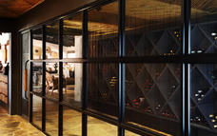

Luxury Room(s)
- Free wi fi
- 24-hour temperature control
- Direct dial telephones
- A mini-bar
- A mini-safe
- Bathroom amenities, insect repellent and hairdryers
- Tea and coffee making facilties

Activities
MalaMala Game Drives
MalaMala Game Reserve
Game Drives
Bush Walks
The Boma
Dining Room

Sabi Sand Private Game Reserve
Adjacent to the Kruger National Park, the Sabi Sand Private Game Reserve is a private premier viewing destination. It was the first-ever private nature reserve established in South Africa. The landscape features 65 000 hectares of savannah-covered land interspersed with watering holes, dry river beds, Lowveld woodlands, and the perennial Sabi and Sand rivers. This spectacular reserve offers exceptional game viewing opportunities with frequent sightings of the renowned Big Five as well as cheetah, zebra, giraffe, and a variety of antelope. Visitors can enjoy excellent wildlife viewing, dining under the stars, guided bush walks and enjoying a stay in some of South Africa’s most luxurious safari lodges.
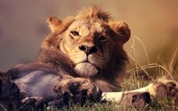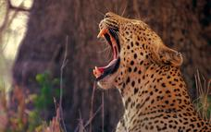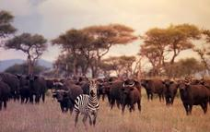

Kruger Private Reserves
Scattered along the unfenced western boundary of the world-renowned Kruger National Park, private game reserves combine with the Kruger to establish one of the world’s largest game reserves. This incredible destination offers visitors excellent Big Five game viewing opportunities and an array of luxury safari accommodation complete with world-class cuisine, relaxing spas and private pools. Visitors can look forward to fascinating night-drive safaris, guided nature walks, and open-top safari adventures. Some of these prestigious private reserves include: Sabi Sands Private Game Reserve, Thornybush Private Game Reserve, and Timbavati Private Game Reserve, to name a few.
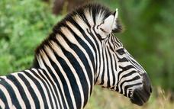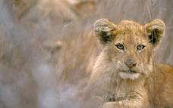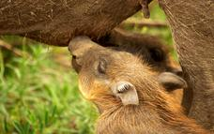

MalaMala Game Reserve
Situated in the northeastern reaches of South Africa in the province of Mpumalanga, MalaMala Game Reserve shares a boundary with the Kruger National Park. MalaMala is one of the largest Big Five game reserves in Southern Africa. Stretching over 13 300 hectares, this spectacular reserve features bushveld, vast savannah, riverine woodlands, and straddles the Sand River. MalaMala is one of the more established private reserves as well as one of the oldest private reserves in the greater Kruger Park region. Commonly spotted animals include lion, leopard, buffalo, elephant and rhino.
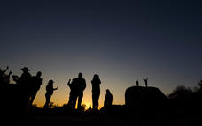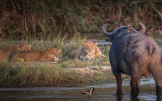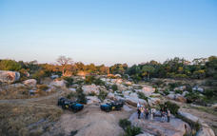

Game Drives
Game drives are conducted twice a day (early morning, and late afternoon/ evening) in open 4-wheel drive safari vehicles. The rangers are in constant radio communication with one another to keep each other informed about the location of wildlife. Headsets are used for this purpose so as not to interrupt the sounds of the African bush. The 4-wheel drive safari vehicles enable the rangers to leave the road and provide guests with close up game viewing and fantastic photographic opportunities. Night drives, with the aid of powerful spotlights, bring the bush to life at night.
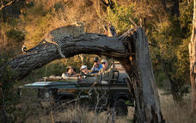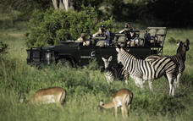

Bush Walks
Visitors may head out on foot with their armed ranger. The perspective of the bush is entirely different to that of a vehicle, and guests will learn to read the signs of the wild, and perhaps come into close contact with the different animal species on the reserve.
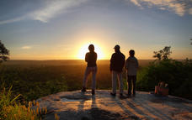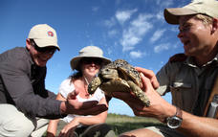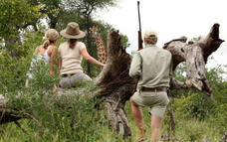

The Boma
Dinners are served under the stars inside a reed "Boma" and around a fire.

Dining Room
Indoor dining. Each of the 3 camps has indoor and outdoor dining facilities.

Basis
Full Board Plus - Dinner, Bed, Breakfast, Lunch and Activities

Day 2: MalaMala Camp, MalaMala Game Reserve (Sat, 31 October)

Day Itinerary
- Sunrise game drive
- Breakfast at the lodge
- Optional Bush Walk
- Lunch at the lodge
- Sunset game drive
- Dinner at the lodge

Activities
Game Drives

Optional
Bush Walks

Game Drives
Game drives are conducted twice a day (early morning, and late afternoon/ evening) in open 4-wheel drive safari vehicles. The rangers are in constant radio communication with one another to keep each other informed about the location of wildlife. Headsets are used for this purpose so as not to interrupt the sounds of the African bush. The 4-wheel drive safari vehicles enable the rangers to leave the road and provide guests with close up game viewing and fantastic photographic opportunities. Night drives, with the aid of powerful spotlights, bring the bush to life at night.

Bush Walks
Visitors may head out on foot with their armed ranger. The perspective of the bush is entirely different to that of a vehicle, and guests will learn to read the signs of the wild, and perhaps come into close contact with the different animal species on the reserve.

Basis
Full Board Plus - Dinner, Bed, Breakfast, Lunch and Activities

Day 3: MalaMala Camp, MalaMala Game Reserve (Sun, 1 November)

Day Itinerary
- Sunrise game drive
- Breakfast at the lodge
- Optional Bush Walk
- Lunch at the lodge
- Sunset game drive
- Dinner at the lodge

Activities
Game Drives

Optional
Bush Walks

Game Drives
Game drives are conducted twice a day (early morning, and late afternoon/ evening) in open 4-wheel drive safari vehicles. The rangers are in constant radio communication with one another to keep each other informed about the location of wildlife. Headsets are used for this purpose so as not to interrupt the sounds of the African bush. The 4-wheel drive safari vehicles enable the rangers to leave the road and provide guests with close up game viewing and fantastic photographic opportunities. Night drives, with the aid of powerful spotlights, bring the bush to life at night.

Bush Walks
Visitors may head out on foot with their armed ranger. The perspective of the bush is entirely different to that of a vehicle, and guests will learn to read the signs of the wild, and perhaps come into close contact with the different animal species on the reserve.

Basis
Full Board Plus - Dinner, Bed, Breakfast, Lunch and Activities

Day 4: End of Itinerary (Mon, 2 November)

Day Itinerary
- Sunrise game drive
- Breakfast at the lodge
- Check out by 11h00
End of Itinerary
PAYMENT DETAILS – Booking # WB2551 - HARRIS
Date Description Total

30/10/2021 MalaMala Camp - 3 nights – 1 x triple room ZAR 54585.00
Including all meals, community levies
& 2 safaris daily – 3 guests sharing
**Gate fees excluded

Rate per/person per/night (SA Residents): ZAR 5900.00 + ZAR 165.00 Community leves
Payment Schedule:
16 October 2020: R 54585.00
Banking Details
Banking Details
Bank | First Rand Limited / First National Bank |  | Branch Code: 250655
Account Name: | African Safaris Network T/A Sabi Sands Lodges Reservations
Account: | 62653087562
Reference  Swift Code: | WB2551-HARRIS  FIRNZAJJXXX
Due Date | 16 October 2020
Amount Due: | ZAR 54585.00
Thank you for booking with Sabi Sands Lodges Reservations

